* + - * 1. FYP PROJECT REPORT

SMART PLANTATION



BS (SE) 2017

**Aimun Tahir 2017/COMP/BS (SE)/21587 1720658**

**Hiba binte Tariq 2017/COMP/BS (SE)/21599 1720675**

**Namrah Komal 2018/COMP/BS (SE)/23118 18558**

**Surayya Obaid 2017/COMP/BS (SE)/21635 1720710**

18th February, 2021

Department Of Computer Science & Software Engineering

Jinnah university for women

5-C Nazimabad Karachi 74600

**Department of Computer Science and Software Engineering**

**Jinnah University for Women**

**Project Approval**

Project Title: Smart Plantation

By:

Aimun Tahir 2017/Comp/BS(SE)21587 1720658

Hiba binte Tariq 2017/Comp/BS(SE)21599 1720675

Namrah Komal 2018/Comp/BS(SE)23118 18558

Surayya Obaid 2017/COMP/BS(SE)21635 1720710

Approval Committee:

___ ____ _____________

Name: Ms. Tehreem Qamar

Designation: Lecturer

(Internal Advisor)

___________________________

(Head of the Department)

# **ABSTRACT**

**Smart plantation** is all about purifying the environment. The plantation is a process that doesn't bring noticeable changes in small duration to the environment. On the other hand, it's one of the causes that has marked lethal impacts on the planet. We can take the example of recent incidents like Amazon Rainforest fire, Australia bush fire, and many more. We have seen in Karachi that heatwave was primarily because of the Conocarpus tree which was massively planted without any prior research. The result was decreased humidity, decreased water level and ultimately KMC had to cut the plant from across the city.

**Smart Plantation** is a solution to the problem of inappropriate plantation by recommending what is needed by the environment. Data with the help of sensors is collected from the air and land. The system then makes a prediction and it is also ensured that the suggested plant is in the approach of the user as they are made able to buy seeds from the app.

# **Acknowledgement**

The team would like to express sincere gratitude to supervisor Ms. Tehreem Qamar for giving us her invaluable time, guidance, support and suggestions throughout the course of this project.

We would like to express our gratitude for all of faculty members and especially Chairperson Dr. Narmeen Bawany, for opening the doors of knowledge and opportunities for us.

# **Chapter 1**

# **INTRODUCTION**

## PURPOSE

With the evolution in technology and other industries, there comes the need to manage their impact on the environment. All the terms that we hear these days like global warming, depletion of earth's resources (like air, water, soil, etc.), destruction in the ecosystem, are the result of this revolution. And it's noticeable that we can't keep ourselves away from the changes that are brought through technology but we can certainly lower down the worsening effect.

Very few people go for research before planting trees. Most of them feel free to plant whatever they want without taking care of how their decision will make an impact on the environment. This can be overcome by deploying a system that is smart enough to suggest a flora as per the environment.

Few factors are considerable for plantation. We can categorize these into two types i.e. factors that affect plants from the soil and those that affect from Air. Another consideration for plantation is that not every plant is suitable for the environment that may benefit in any other area. For example, Heat wave in 2015 was slight because of Conocarpus Tree that was massively planted in 2008 without any research[1]. The tree itself has no ill effect but its plantation isn't suitable for our environment[2]. Researchers say that the plant's roots extend horizontally which causes two things. First, due to extended roots, it absorbs a huge amount of water from the soil that ultimately results in decreased humidity in the Air. And apart from this issue, its roots are strong enough to penetrate solid objects destroying man-made structures like service lines and other vital facilities. So the plantation of Conocarpus near residential areas isn't appropriate and should be avoided in Karachi too.

Another example is of Paper Mulberry trees that are planted in the country's capital, Islamabad[3]. These trees release pollen twice a year resulting in Air pollution. Although they add beauty to the landscape, on the other hand, they are the cause of an increased number of Asthma patients in the city. Again, Tree itself isn't harmful; rather its specifications aren't compatible with the environment.

## Product Scope

The proposed system covers predictions for plants according to the indoor and outdoor environment. For such predictions, the network of sensors is used which takes and delivers the measures of current temperature, humidity, concentration of oxygen, carbon dioxide etc. which is all needed for a plant to be grown properly.

## Overall Description

Smart Plantation is a solution for the problem of an inappropriate plantation by recommending what is needed for the betterment of the environment. As the reversal of the process of plantation is so costly, it’s preferable to do it precisely in first attempt. Therefore this system is making prediction and also it is ensured that the suggested plant is in approach of the user.

 Data from the environment is collected with the help of a network of sensors which includes data of temperature, humidity, the concentration of oxygen and carbon dioxide in the air, concentration of salt, nitrogen, water, etc.  in the soil. Based on this data, the system suggests a plant enlisted in the database of the system that has the most matched features with the environment.

Apart from the prediction of suitable plants, the system also ensures the availability of seeds of the suggested plant so that the user can buy the seed of a recommended plant from the same place. Some people don't get satisfied with the outcomes and recommendations made by the machines that is why the system side by side provides the consultation services from professional gardeners so that users get deserved satisfaction.

As masses are gaining awareness about the need for plantation, there comes the need for a force that helps in channelizing campaigns for plantation. The idea of involving community or neighborhood in restoring forest and urban green habitats turned out to be successful in Philippines as they were able to regrow forest on vast area[4]. Therefore we are assisting users who are intended to donate for the areas that need plantation critically by helping them in initiating plantation campaigns.

### [Product Perspective](http://www.cloudbus.org/cdn/reports/SRS_CDN%20Peering.pdf)

The product is an IoT project that is intended to provide a smart solution to environmental pollution. It is accessible through the web as well as an android application. Few sections like E-commerce of plants are overlapped on both the website and mobile application while few like Plant suggestion (through mobile), hardware purchasing (through the website) are restricted to a particular platform.

#### Initiation

The system is initiated by signing up followed by logging in.

#### Device Connection

User has to buy device in order to go further for suggestion of plant. Device is then connected by entering serial number provided on device.

#### Plant suggestion

Data collection begins after the device connection and data obtained, is processed in order to make suggestion for plant in accordance with needs of that particular environment.

The process can be followed by acquiring gardeners’ services, purchasing seeds and donation for plantation campaigns.

### [User Characteristics](https://aakashtechsupportdocs.readthedocs.io/en/latest/prodpersp.html)

It is considered that the user does have the basic knowledge of operating the internet & smartphone.

The administrator is expected to be familiar with the interface of the tech support system. Basic knowledge to handle hardware equipment will be required for the user.

### Operating Environment

This is a web plus app-based system and hence will require the operating environment for a client and server GUI. This software highly depends on the type and version of the browser being installed in the system i.e. browser version should be used which have HTML5 support.

### Design And Implementation Constraints

* Android Application is usable on the devices with API level 23 or greater.
* Large data storage is required for efficiency of system as database of native plants and their characteristics is massive.

### User Documentation

Users will be provided with support to handle possible issues of the device along with software queries under the Frequently Asked Questions (FAQs) section.

### Assumption And Dependencies

#### Assumptions

* The people having lawns or gardens in their homes will prefer using this application.
* Plants will be available in our online nursery when a customer would need it.
* Product delivery will be done without any un-required delays.
* The hardware cost won’t be unreachable for our customers.
* Our gardener’s services will be helpful for our users.

#### Dependencies

* Our services through a mobile application are highly dependent on the purchase of the hardware module by the user.
* The suggestion of plants will be done via application only

## System Features

* The system fulfills the requests of the device and proceeds orders.
* The device gathers data from the environment for a certain period of time.
* The system processes data and suggests a plant in accordance with the environment’s characteristics and needs.
* The system lets the user buy suggested plants through an e-commerce module.
* The system facilitates users by enlisting gardeners so that they can utilize the services of a gardener.
* The system channels up donation campaign by providing user opportunity to donate for plantation campaigns.

## Other Non-Functional Requirements

### Performance Requirement

The system should have excellent response time and execution efficiency.

### Safety Requirement

The hardware unit of the system should not bring any harmful impact on the lives of plants and environment.

### Security Requirement

Data of the system must be stored securely.

## Software Quality Attributes

### Reliability

The system works smoothly while there’s a change in atmosphere, every day.

### Accuracy And Precision

The suggestions and summaries made by the system are free from inaccuracy.

### Understandability & Usability

There is an understandable interface of a system that is easy to operate for the user.

## Business Rules

* Payment is done on delivery.
* No order after 3 days is considered for review.
* Services charges from gardeners is given directly to them.

# Chapter 2

# **ANALYSIS AND DESIGN**



## Workflow Diagram

The diagram includes all possible steps user may have to go through. For retrieving data from device, the first step required is device connection which can be either denied or accepted by the system depending upon the key entered for validating device. Later steps include plant suggestion and monitoring along with gardening, donation and plants e-commerce module.

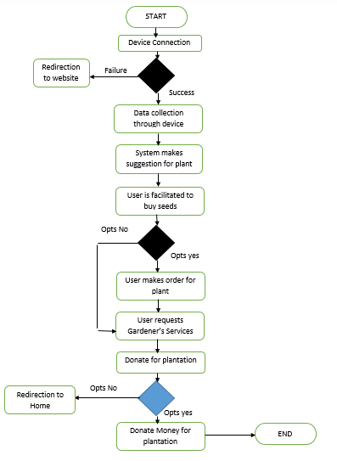

Figure 2.0‑ Workflow Diagram

## Relational Model

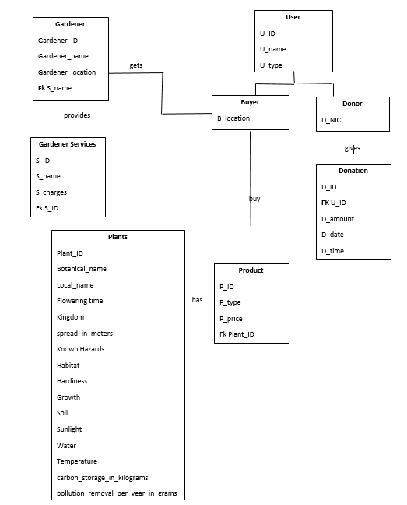Relational model here shows the relation between entities and their attributes. It also shows how data between entities is shared with the help of foreign keys.

Figure 2.‎‑ Relational Model

## Use Case Diagram

There are two cases for use case diagram i.e. buyer and donor. Figure 2.3 is use-case diagram of Buyer which shows all possible use cases of user. Users can **Sign-up, log-in, buy hardware unit** to **get plant suggestion** and to **track plant**. Users can also **request for gardener’s** and is also provided the facility to **buy plants** suggested to them from plant store.

## 

Figure ‑ Usecase Diagram (Buyer/User)

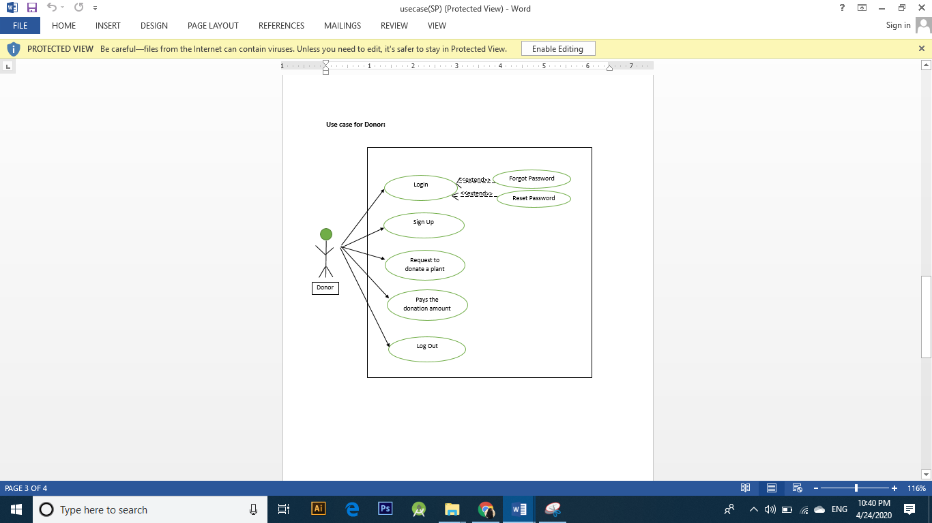Figure 2.4 represents use cases for donor. It isn’t necessary for all users to donate for plantation campaigns but those who do, have to do some extra steps including **request to donate for plant** and **payment of donation amount**.

Figure 2.0‑ Usecase Diagram (Donor)

## Entity Relationship Diagram

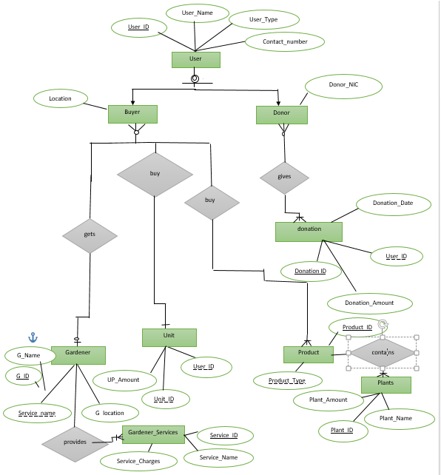ER Diagram represents the logical view of relationship between entities along with the cardinalities defined to show the grouping mechanism. Here, there are 9 entities including user (further divided into buyer and donor), Garden_payment, Product_payment, donations, Unit, Product, Gardener, Gardener_Services, Unit_Payment and Plants. Entities are shown with all potential attributes along with primary key and foreign keys.

Figure 2.0‑ Entity Relationship Diagram

## Data Flow Diagram (Level 1)

Data Flow Diagrams here represent following:

* User can acquire gardener’s services data, which are shared with the user on the basis of location they enter.
* User can visualize the data collected by the device, with the help of mobile application.
* User can also buy plants from plants store that are listed on website and mobile application.
* 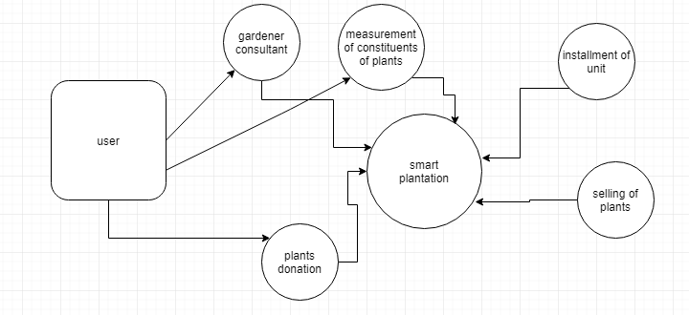User can proceed for donating for plantation campaigns being carried out in nearby area.

Figure 2.‑ DFD (level 1)

## Data Flow Diagram (Level 2)

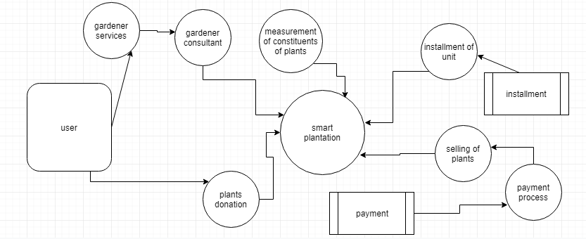

Figure 2.‑ DFD (level 2)

## Architecture Diagram

Architecture diagram here discloses the communication between components such as of Web API controller and Android client with presentation layer i.e. front-end of mobile app and website. It also shows the data journey from SQL database till user end.

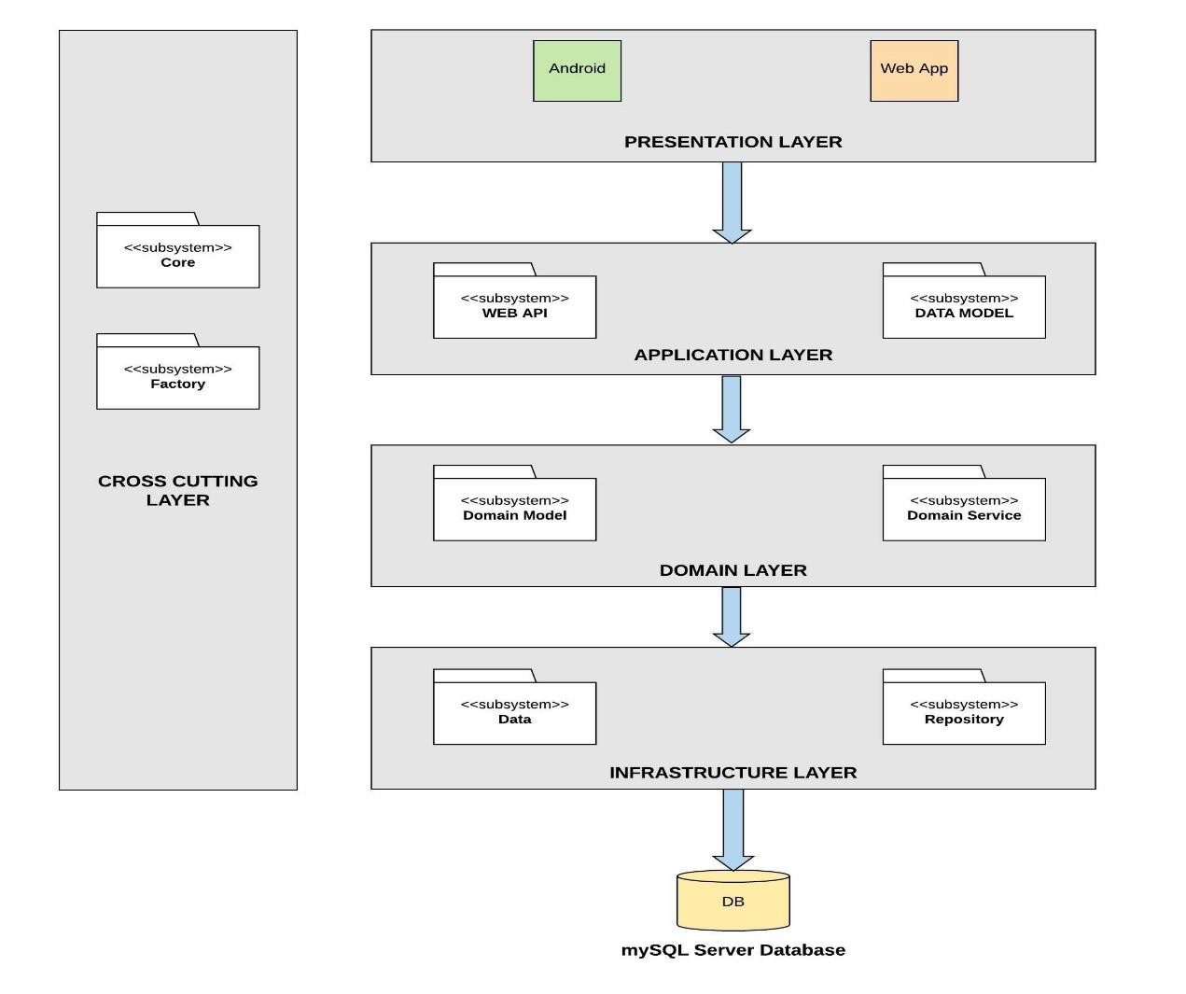

Figure ‑ Architecture Diagram